Objects
An object is a special kind of data type/variable that can hold many values (like an array) which each have an associated key/name to access them. Very similar to associative arrays in PHP. Objects can also hold functions known as methods which can be performed on the object itself.
Think of an object as a fancy form of an array. In an array you access items via their indexed position newArray[ 0 ]. For objects we use the item’s key newObject[ "city" ] or newObject.city.
const newArray = [ - const newObject = {
"Vancouver", - city: "Vancouver",
2021 - year: 2021
]; - }
Another difference is that arrays store items in specific positions known as indexes. The last item added to an array will be in the last position. Objects don’t have an order to their items (items are called properties in objects). If you add a new property to an object you can’t trust that it is in the last position.

Defining or Creating an Object – the Literal Way
The easiest way to create your own object is to create an object literal. Like all variables, you must declare the object name with const, let or var and then use curly brackets {} to hold all the values you want to put inside of it. Note that like an array, declaring an object using const still allows you to make changes to the object later in the code. So long as you don’t change the data type of the object, const won’t prevent you.
const myObject = { myFirstName : "James" , myLastName : "Finn" , myAge : 38 };
const myObject = { myFirstName : "James" , myLastName : "Finn" , myAge : 38 };
myObject contains 3 items/properties: two strings (‘James’ and ‘Finn’) and a number (38). Each value is given or assigned a name/key to identify it. The colon ( : ) separates the key from the value. The key appears on the left while the value appears to the right of the colon. These assignments are all separated from each other by commas (,). Make sure that the last value declared in the object is not followed by a comma.
Below is the object declaration once again (also referred to as object definition) again without all the colouring. Notice how we can drop to a new line after each assignment.
const myObject = {
myFirstName : "James",
myLastName : "Finn",
myAge : 38
};

How to access Properties in an Object
There are 2 ways to access properties within an object. In all cases you must use the name of the object and its property key:
- objectName.propertyName myObject.myFirstName;
  - alert( myObject.myFirstName ); // Alerts "James"
  - alert( myObject.myLastName ); // Alerts "Finn"

- objectName[ “propertyName” ] myObject[ "propertyName" ];
  - alert( myObject[ "myFirstName" ] ); // Alerts "James"
  - alert( myObject[ "myLastName" ] ); // Alerts "Finn"
*This system of accessing properties is probably the best since it can be used in for in loops. Since you pass in the key of the property as a “string” you have more systems available to you.

Adding new Properties to existing Objects
Adding a new property to an already existing object is very simple. All you need to do is state the name of the object followed by the name of the new property followed by assigning it a value.
objectName.newPropertyName = newValue
myObject.myNationality = "Irish"; or myObject[ "myNationality" ] = "Irish";

Updating Properties in existing Objects
You can update a property’s value simply by using an existing property name and assigning it a new value.
myObject.myFirstName = "Kevin"; or myObject[ "myFirstName" ] = "Kevin";

Object Properties or Methods – the 2 types of things stored in an object
It’s important to note at this stage that there are 2 types of things stored in an object. These are referred to as properties and methods:
- Properties – are named values. Think of them as a basic variable. In the example above, everything inside myObject is a property.
- Methods – are functions defined inside objects that can perform actions on objects.
Let’s use a real-world object, a mobile phone, to demonstrate the difference between properties and methods.
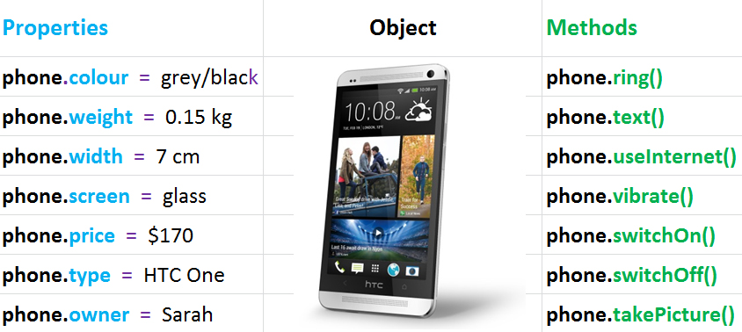

The main difference is that properties are values while methods refer to actions.
Property is a noun Method is a verb
Property is a variable Method is a function

How to store Methods in an Object
We have already seen how to put a property into an object when creating one. We assign the key to the value using the semicolon ( { key : value, key : value } ). Adding a method is similar. Like the property a method has a name or key assigned to it. In the place of the value however, we will put an anonymous function (a function without a name).
const myObject = {
myFirstName: "James",
myLastName : "Finn",
myFullNameFunc : function() {
alert( this.myFirstName + " " + this.myLastName );
},
myAddressFunc : function( para ) {
alert( "I live in " + para );
}
};
Inside the brackets of our anonymous function, we put the code we’d like to execute when we call the method. Notice how inside a method, when we want to refer to other properties inside the same object, we have to place the reserved keyword this in front of the property name. Now when the myFullNameFunc() method is called it will create an alert box that says: “James Finn”. In these circumstances, this refers to the parent object.
Also note that despite the method being an anonymous function, since we assigned it the name/key myFullNameFunc we need to use that when calling it. Of course, methods inside objects can have parameters as well. The method called myAddressFunc() shows this being used. You still must use the parenthesis () after the method name/key when wanting to use it.

So now we know how to create an object and give it both properties and methods. The next step is learning how to call methods from an object.

How to Call Methods in an Object
Calling a method/function that is inside an object is done in a similar fashion to accessing properties. You first must state the name of the object followed by the name/key of the method:
objectName.methodName() myObject.myFirstNameFunc();
myObject.myFirstNameFunc(); // Alerts "James Finn"
myObject.myAddressFunc( "Vancouver" ); // Alerts "I live in Vancouver"

Adding new Methods to existing Objects
Adding a new method to an already existing object is very simple.
objectName.newMethodName = newValue
myObject.newMethod = function () {
alert( "New Method" );
}

The this Keyword
In JavaScript when we use the this keyword we are referring to the object that “owns” the section of the code. In the example above our object, myObject, contains all the properties and methods, so when we use this we are referring to myObject. Using this we can get access to other properties or methods inside the same object.
Generally speaking, in JavaScript however, the this keyword is more complicated. When asked what does this refer to in JavaScript the correct answer is “depends on where it is being used and what is using it”. A regular function using this would refer to the object that called the function which is more than likely the global window object (think of this as the entire webpage). In an event, like a button being clicked, this would refer to the actual element itself - that would be the button in this case. Be careful with arrow functions however as they treat this differently than normal functions. In general, this in an arrow function will always refer to the global window object.
const objExample = {
name: "James",
normalFunction: function() { // Normal anonymous function
console.log( this.name ); // Will log “James”
},
arrowFunction: () => { // Arrow function
console.log( this.name ); // Will log “undefined”
}
}

Looping through an Object – for…in loop
The for in loop is used in JavaScript to loop through the properties of an object. The variable we create here which we called prop, assumes the property key during each loop or iteration. The object we want to loop through, which in this case is myObject, is placed to the left of in. Take note however that to display the property value you need to use the [] version of accessing it. Using the myObject.property system will not work here. In the below example an alert will be made for every property in myObject and the property name will be shown beside the property value.
for ( let prop in myObject ) {
alert( prop + " " + myObject[ prop ] );
}

*Note that this will also iterate over the method keys present inside the object, not just the properties. If you want to avoid methods in loops, it’s best to write a conditional that will exclude them.
for ( let prop in myObject ) {
if ( typeof prop !== "function" ) {
// alerts only properties and no methods
alert( prop + " " + myObject[ prop ] );
}
}

Useful Object Functions
Using the object we created above called myObject, let’s see some useful in-built JavaScript functions that work on objects.
myObject.hasOwnProperty( prop ) returns true or false based on whether the object
has a property with the key provided in prop
e.g. myObject.hasOwnProperty( "myFirstName" ); // returns true

Object.getOwnPropertyNames( object ) returns an array containing all property/method
keys contained in object.
e.g. Object.getOwnPropertyNames( myObject ); // returns [“myFirstName”, “myLastName”,
“myFullNameFunc”, “myAddressFunc”]

OOP Object Orientated Programming
OOP is a programming paradigm used to describe a system for writing code based around objects and their properties and methods. It is a programming model organized around objects rather than "actions" and data rather than logic.
You will often hear people state that JavaScript and Python are object orientated programming languages even though you don’t have to write code in that style. The reason for this is that all elements in both languages are essentially treated like objects. This might sound confusing, but it is technically true. If you look at the inbuilt JavaScript functions/methods that you’ve been using with strings, numbers, arrays etc., you might have noticed something.

myString.toUpperCase();
myNumber.toFixed( 2 );
myArray.indexOf( "string" );

Just like we call methods inside of objects that we created, here we apply the same system to variables that we’ve created. This shows that strings, numbers, arrays etc., all have inbuilt object methods on which we can exploit.

